Michael Redford
25 Feb 17
IS315

Process Analysis

Our process have been divided down to 3 sub processes for the sake of clarity. This will clearly define what is our processes are to cover the actions of the staff, managers, and maintainers.

Order Process

Our order and inventory system is only used in house. The “customer” is the staff who requests reports, inventory status, and review inputs.

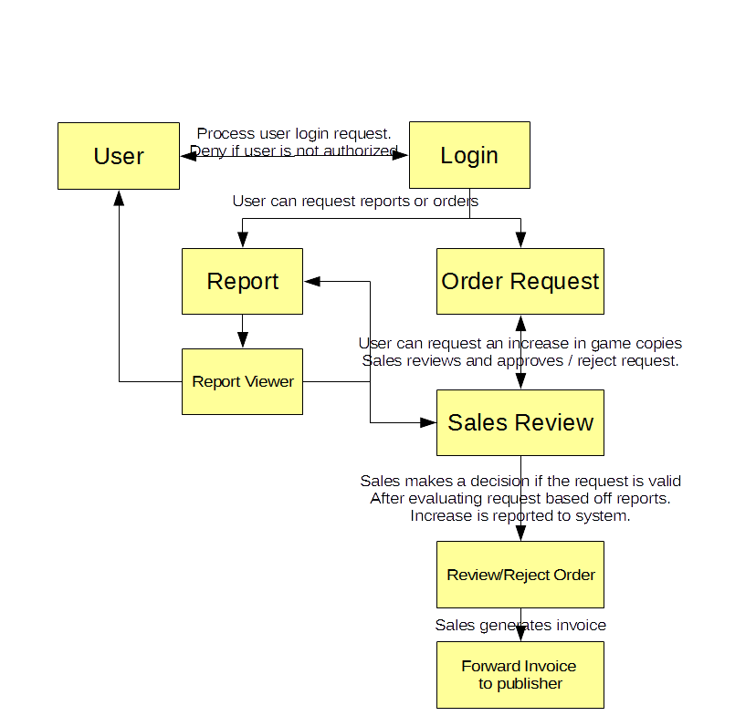

Staff Process

The staff views the reports and information generated by the system.
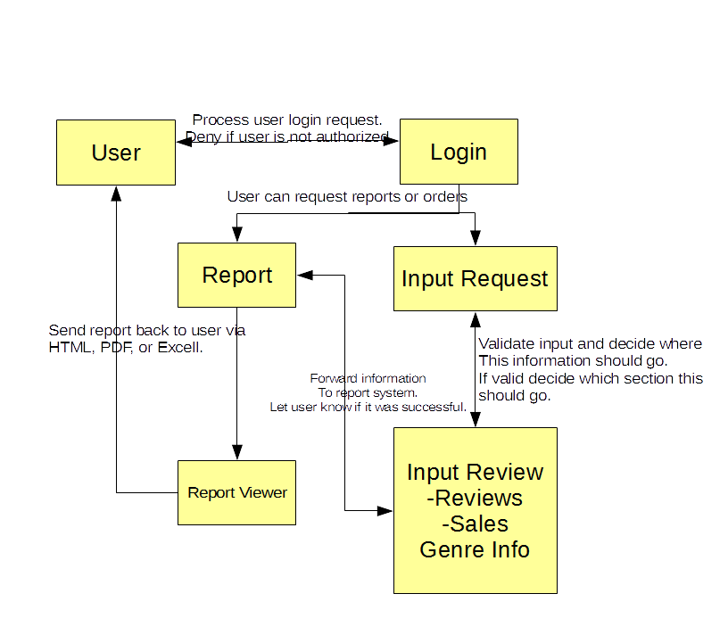

Management and Maintenance Process

Management requests reports to gain information on the current performance of sales inventory and reviews. Maintainers can update the system and provide management with info on the current status.

